**Biology: 2. Cells and the Microscope**

***Please remember to photocopy 4 pages onto one sheet by going A3→A4 and using back to back on the photocopier***

**Syllabus**

**OB42**  Identify, and understand the functions of, the main parts of a microscope (light microscope only) and use it to examine an animal cell and a plant cell

**OB43** Draw one example each of an animal cell and a plant cell, identifying the nucleus, cytoplasm and cell wall (plant cell), and indicate the position of the cell membrane

**OB44** Prepare a slide from plant tissue and sketch the cells under magnification

**Student Notes**

**The microscope**

Organisms (living things) are made up of cells. Cells differ in shape, size and function.

The microscope can be used to examine plant and animal cells.

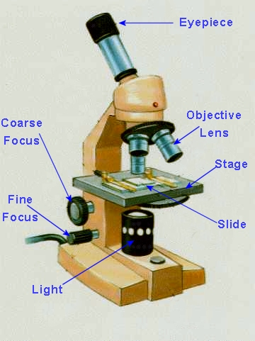

|  |  |
| --- | --- |
| **Component** | **Function** |
| **Eyepiece** | Magnifies the image |
| **Focus wheels** | Focuses the image |
| **Objective lenses** | Magnifies the image |
| **Stage** | Supports the Slide |
| **Slide** | The specimen is placed on the slide |
| **Light-bulb** | Light source |

**To prepare plant cells for viewing under a microscope**

1. Place a drop of iodine onto a clean glass slide (iodine is used to stain (‘dye’) a cell and make it easier to see).
2. Cut an onion and remove a thin layer of inner cells.
3. Place it on the slide and place a cover slip on top.

**To prepare animal cells for viewing under a microscope**

1. Use a cotton swab to get cheek cells and smear this onto a slide.
2. Put a couple of drops of methylene blue stain on the smear and leave for a few mintues.
3. Rinse off the stain and allow the slide to dry.

**To examine a plant or animal cell under a microscope**

1. Put a piece of tissue on the slide and cover it with a glass slip.
2. Place the glass slide on the stage and secure with clips.
3. Watch from the side and turn the coarse focus wheel so that the objective lens is as close to the stage as possible.
4. Put your eye to the eyepiece and gently turn the fine focus wheel the opposite way to sharpen the image.



|  |
| --- |
| **Animal Cell** |
| http://www.teachnet.ie/tburke/cell/animalcell2.jpg |

|  |
| --- |
| **Plant Cell** |
|  |

|  |  |
| --- | --- |
| **Part** | **Function** |
| Cytoplasm | Most of the cell’s activities happen here |
| Cell membrane | Holds in the contents of the cell and controls what enters and leaves the cell |
| Nucleus | Controls the activities of the cell |
| Vacuoles | Store food |
| Cell wall | Provides support and structure to plant cells |
| Chloroplasts | These contain chlorophyll which makes food for plant cells |

|  |  |
| --- | --- |
| **Differences between plant and animal cells** | |
| **Plant Cell** | **Animal cell** |
| Cell wall | No cell wall |
| Chloroplast | No chloroplast |
| Large vacuole | Small, if any, vacuoles |

Question: Why do animal cells not need chloroplasts?

**Did you know??**

* Humans shed and re-grow outer skin cells about every 27 days. Skin protects your delicate internal organs from the elements and as such, dries and flakes off completely about once a month so that it can maintain its strength. Chances are that last month’s skin is still hanging around your house in the form of the dust on your bookshelf or under the couch.
* Three hundred million cells die in the human body every minute. While that sounds like a lot, it’s really just a small fraction of the cells that are in the human body. [Estimates](http://ask.yahoo.com/20020625.html) have placed the total number of cells in the body at 10-50 trillion so you can afford to lose a few hundred million without a hitch.
* Every day an adult body produces 300 billion new cells. Your body not only needs energy to keep your organs up and running but also to constantly repair and build new cells to form the building blocks of your body itself.
* Your stomach lining replaces itself every 3 days, your skin every month and your skeleton every 10 years!
* The cell is made up of parts that were originally bacteria – so how did they become part of the cell?
* 90 % of the cells in our body are bacteria.   
  About 32 million bacteria call every inch of your skin home.
* Forget the distinction between life as being either Plant or Animal; the following is a more apt description.  
  Bacteria and blue-green algae lack the internal structures of higher cells. They have no nucleus, chromosomes, chloroplasts or mitochondria (the ‘energy factories’).  
  They are known as “pro-karyotic” (“before nuclei”; *karyon* means “kernel”).
* Cells with these structures are known as “eukaryotic” (‘truly nucleate’).
* See weird science and ted.com  
  http://multimedia.mcb.harvard.edu/anim_innerlife.html
* Make sure to look at the Harvard site for a look at how incredible cells actually are.

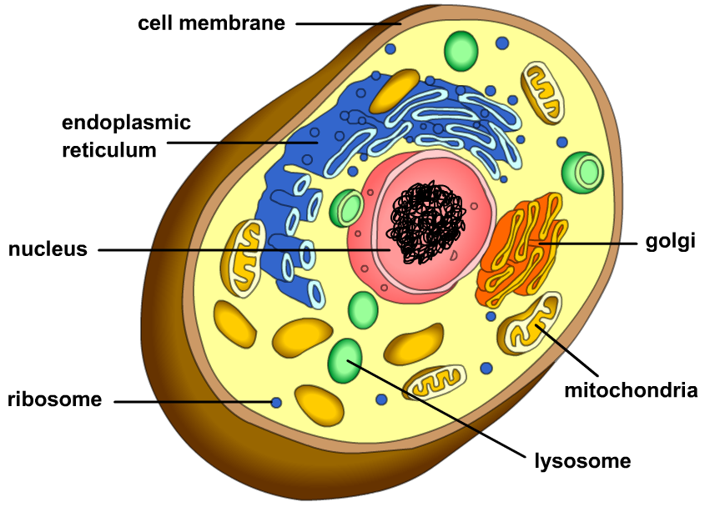**Exam Questions**

1. [2007 OL]

The picture shows a piece of laboratory equipment.

1. Name the piece of equipment.
2. Give one use of this piece of equipment.
3. [2011 OL] [2008 OL] [2012 OL]

|  |
| --- |
| Lens |
| Lamp |
| Eye piece |
| Focus wheel |
| Base |
| To focus |
| To magnify |

The diagram shows a microscope.

Study the diagram and answer the questions below using the words in the table.

1. What is the name of the part labelled A?
2. What is the name of the part labelled B?
3. What is the name of the part labelled C?
4. What is the function of the part labelled B?



1. [2009] [2006]

The parts labelled A and B in the diagram of the microscope work together to perform a single function.

1. What is the combined function of A and B?
2. Name the part labelled C in the diagram.
3. [2006]

Onion epidermis is a tissue only one cell thick.

It is used in school laboratories on microscope slides to investigate plant cell structure using a microscope.

Describe how to prepare a microscope slide from a plant tissue.

1. [2011 OL]

Cells are an important structure in living things.

1. Which part forms the outer part of plant cells?
2. Which part forms the outer part of animal cells?
3. Name a part found in plant cells only.
4. Which part controls the activities and reproduction of the cell?
5. [2008 OL]

The diagram shows an animal cell and a plant cell.

Which is the plant cell and which is the animal cell?

1. [2010 OL] [2010][2012 OL]

The diagram shows a plant cell.

Name the parts of the cell labelled A and B.

1. [2011]

The diagram shows an animal cell.

1. Name part A
2. What important structures are located in B?
3. [2006]

Draw a labelled diagram of a plant cell.

**Exam Solutions**

2. Microscope
3. Examining cells
4. Eyepiece / Lens
5. Focus wheel
6. Lens
7. Focus
8. To magnify the image/ magnification
9. Stage: to hold (or support) the slide (or specimen)
10. Place the glass slide on the stage and secure with clips.

Put the piece of tissue on the slide. Cover it with a glass slip.

1. Cell wall
2. Cell membrane
3. Cell wall, chloroplast
4. Nucleus
5. Animal cell on top, plant cell on the bottom
6. A is the cell wall and B is the nucleus
7. A: membrane
8. B: chromosomes/ genes/ DNA
9. See diagram

**Other Test Questions**

1. Draw a labelled diagram of a microscope including all major parts.
2. Draw a labelled diagram of an animal cell and list the function of each part.
3. Draw a labelled diagram of an animal cell and list the function of each part.